Real-Time Drone Inspection for Irrigation Pipeline Leaks

abdulrhman salah aldossary
Department of Computer Networks and Communications King Faisal University Al Hofuf, Saudi Arabia 223003831@student.kfu.edu.sa
khaled radwan alqahtani
Department of Computer Networks and Communications King Faisal University Al Hofuf, Saudi Arabia 223031191@student.kfu.edu.sa

saud maher alsaleh
Department of Computer Networks and Communications King Faisal University Al Hofuf, Saudi Arabia 223037886@student.kfu.edu.sa

Abstract— Water leakage in irrigation pipeline networks represents a major challenge for sustainable agriculture, particularly in arid and semi-arid regions such as Al-Ahsa, where water resources are limited and agricultural activities rely heavily on efficient irrigation systems. Undetected leaks in underground pipelines can persist for extended periods, leading to significant water loss, reduced irrigation efficiency, soil degradation, and increased operational costs for farmers and water authorities. Early detection of such leaks is therefore essential to ensure optimal water usage and long-term sustainability. Recent advances in unmanned aerial vehicle (UAV) technology and thermal sensing have enabled new approaches for non-invasive inspection of buried infrastructure. Thermal imaging allows detection of surface temperature anomalies caused by subsurface water leakage, making it a suitable tool for monitoring irrigation pipelines. This paper presents a MATLAB-based simulation framework for real-time inspection of irrigation pipelines using a UAV equipped with a simulated thermal sensor. The proposed system integrates thermal and mathematical modeling, UAV motion planning using a lawnmower scanning strategy, leak detection logic, and performance evaluation metrics. Simulation results demonstrate that the proposed approach can effectively detect leaks, achieve high scan coverage, and provide timely alerts, highlighting its potential as a scalable and cost-effective inspection solution.
Keywords— UAV inspection, thermal imaging, irrigation pipelines, leak detection, MATLAB simulation, agricultural water management

Introduction

Agriculture is one of the largest consumers of freshwater resources worldwide, particularly in regions characterized by limited rainfall and high evaporation rates. In such environments, efficient irrigation systems are critical to maintaining crop productivity and ensuring food security. Irrigation pipelines play a central role in delivering water from sources to agricultural fields; however, these systems are often extensive, aging, and buried underground, making routine inspection and maintenance challenging.
Water leakage from irrigation pipelines can occur due to material degradation, pressure fluctuations, improper installation, or environmental factors such as soil movement. These leaks may remain undetected for long periods, especially when they do not produce visible surface indicators. Over time, undetected leaks can lead to significant water loss, uneven water distribution, increased pumping costs, and reduced agricultural yield.
Traditional pipeline inspection methods typically involve manual field surveys, pressure monitoring, or ground-based sensors. While these approaches can be effective in limited scenarios, they are often impractical for large agricultural areas due to high labor requirements, limited coverage, and slow response times. Moreover, manual inspection may require excavation or physical access to pipelines, increasing maintenance costs and disrupting agricultural activities.
The emergence of UAV technology has introduced new possibilities for infrastructure inspection. UAVs can rapidly cover large areas, access difficult terrain, and carry a variety of sensors. When combined with thermal imaging, UAVs can detect temperature anomalies associated with underground water leaks, providing a non-invasive and efficient inspection method. This project explores the feasibility of such an approach through simulation, focusing on irrigation pipelines in agricultural environments.

Problem Definition and Motivation

The primary problem addressed in this study is the lack of efficient, scalable, and proactive inspection methods for detecting leaks in irrigation pipeline networks. Many agricultural systems rely on reactive maintenance strategies, where leaks are repaired only after visible damage, water pooling, or system failure occurs. This approach results in unnecessary water loss and increased repair costs. Manual inspection of underground pipelines is labor-intensive and often impractical for large-scale agricultural networks. Ground-based sensing solutions, such as acoustic or pressure sensors, require installation along the pipeline and may be affected by environmental noise or soil conditions. Additionally, these systems may not provide precise leak localization. The motivation for this work is to develop a UAV-based inspection framework that can detect leaks early, reduce water waste, and minimize human intervention. By using MATLAB simulation, the proposed system allows evaluation of inspection strategies, detection algorithms, and performance metrics without the cost and risk associated with real-world deployment. This approach aligns with the recommendations of Osaro et al. (2024), who emphasize the importance of simulation-based validation in UAV inspection system development.

Related Work
AV-based inspection has gained significant attention in recent years for monitoring infrastructure such as oil and gas pipelines, power transmission lines, and transportation networks. UAVs provide advantages in terms of mobility, cost efficiency, and reduced inspection time compared to traditional methods. Osaro et al. (2024) discuss the use of UAVs for infrastructure inspection and emphasize the importance of integrating sensing technologies with intelligent data analysis. Their work highlights the potential of UAV-based systems to improve inspection efficiency while reducing operational costs. Thermal imaging has been extensively studied for leak detection applications. Zhang et al. (2023) demonstrated that UAV-mounted thermal cameras can successfully detect underground pipeline leaks by analyzing surface temperature anomalies. Their findings confirm that thermal sensing is effective even when the UAV is not directly above the leak source, as long as the anomaly lies within the sensor footprint. Despite these advances, many studies rely on real-world experiments, which can be expensive and difficult to scale. Simulation-based approaches offer a practical alternative by enabling controlled evaluation of system behavior. The proposed MATLAB-based framework builds upon previous research by combining UAV motion planning and thermal modeling in a simulation environment tailored for agricultural irrigation systems. While Zhang et al. (2023) demonstrated successful thermal leak detection using UAVs in real environments, their study highlights challenges related to environmental variability and flight constraints. Factors such as wind speed, solar radiation, and surface material properties can influence thermal signatures, potentially affecting detection reliability. Osaro et al. (2024) emphasize the importance of simulation in early-stage UAV system development. They argue that simulation enables systematic testing of sensing strategies and mission planning algorithms before real-world deployment. This perspective supports the approach adopted in this project, where MATLAB simulation serves as a validation platform for UAV-based thermal inspection. Compared to previous studies, this project places greater emphasis on agricultural irrigation systems, which differ significantly from industrial pipelines in terms of burial depth, soil conditions, and environmental exposure. By focusing on agricultural contexts, the proposed framework addresses a research gap in UAV-based irrigation infrastructure monitoring.

System Architecture
The proposed system architecture consists of four main components:
A. UAV Platform
A quadrotor UAV model is simulated using MATLAB/Simulink UAV Toolbox. The UAV is capable of autonomous navigation and waypoint following. Waypoints are defined along the irrigation pipeline path to ensure full coverage during inspection.
B. Thermal Imaging Sensor
A thermal imaging sensor is simulated and mounted on the UAV. The sensor captures surface temperature data at regular intervals. Sensor parameters such as resolution and sampling rate are configured to represent realistic thermal imaging conditions.
C. Data Processing and Alert Module
Thermal data collected by the UAV is processed in real time. Temperature values are compared against background thresholds to identify anomalies. When a potential leak is detected, an alert is generated containing the location and time of detection.
D. Return-to-Base Mechanism
An automatic return-to-base (RTB) logic is implemented to allow the UAV to safely return after mission completion or leak detection, improving operational safety and energy efficiency.

Thermal and Mathematical Modeling
Thermal modeling is a fundamental component of the proposed system. The surface temperature distribution is represented using a two-dimensional grid, where each cell corresponds to a temperature value. Ambient temperature variations are modeled using stochastic noise to reflect realistic environmental fluctuations. Pipeline leaks are simulated as localized thermal hotspots using Gaussian distributions. This mathematical model approximates the diffusion of heat from an underground leak to the surface. Parameters such as hotspot intensity and spatial spread can be adjusted to represent leaks of varying severity. Mathematical modeling is also applied to UAV motion and sensing. The UAV trajectory is represented as a sequence of discrete positions, and the thermal sensor footprint is modeled as a circular region beneath the UAV. Thermal values within this region are analyzed to determine the presence of anomalies. Thermal behavior at the surface is influenced by multiple physical processes, including heat conduction, evaporation, and solar radiation. Although the proposed model simplifies these processes, the Gaussian-based hotspot representation captures the essential characteristics of thermal leakage patterns observed in practice. The use of stochastic noise in ambient temperature modeling enhances realism by introducing variability similar to natural environmental fluctuations. This prevents the detection algorithm from relying on idealized conditions and improves its robustness. Mathematical modeling of UAV sensing is equally important. By representing the sensor footprint as a circular region, the system accounts for the spatial extent of thermal sensing. This modeling choice reflects real thermal cameras, which capture temperature information over an area rather than a single point. Figure 1 illustrates the simulated thermal environment used in this study, where ambient surface temperature variations and a localized thermal hotspot representing an underground pipeline leak are modeled.
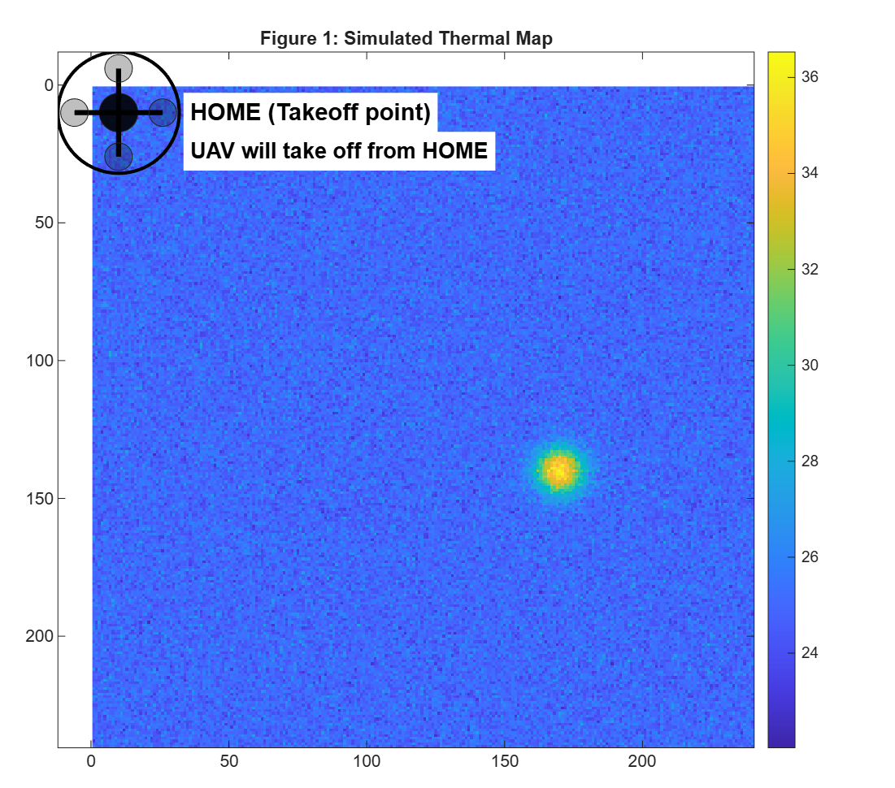Fure 1. Simulated thermal map generated in MATLAB, showing ambient surface temperature distribution and a localized thermal hotspot representing an underground irrigation pipeline leak. The HOME position indicates the UAV takeoff location.

Methodology
The proposed methodology follows these steps:
- Mapping irrigation pipeline paths using predefined coordinates.
- Defining UAV waypoints corresponding to pipeline geometry.
- Simulating a thermal environment with injected leak anomalies.
- Autonomous UAV navigation along the pipeline route.
- Continuous thermal data acquisition and real-time anomaly detection.
- Alert generation and logging of detected leaks.
To ensure complete inspection of the irrigation pipeline corridor, a lawnmower scanning strategy was implemented, as shown in Figure 2.
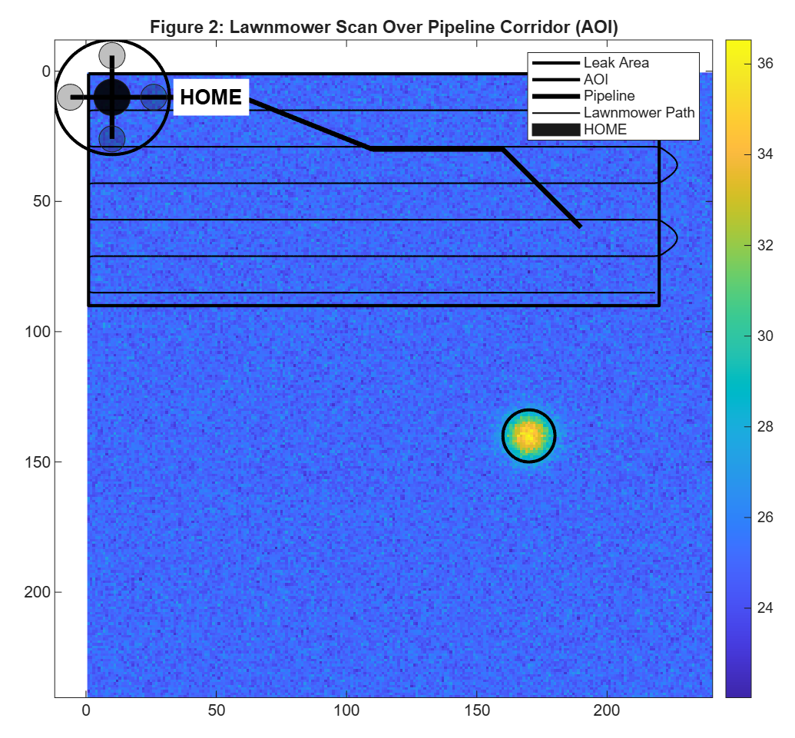
Figure 2. Lawnmower scanning path executed by the UAV over the defined area of interest (AOI), including the irrigation pipeline layout, leak area, and HOME takeoff point.

Simulation Setup
he simulation is implemented in MATLAB, providing a flexible platform for modeling UAV motion, thermal behavior, and detection logic. The inspection area is discretized into a grid, and thermal values are assigned based on the modeled environment.
UAV motion parameters such as speed, heading, and turning behavior are dynamically adjusted to simulate realistic flight dynamics. Visualization tools are used to display UAV trajectories, thermal maps, and detection events.

Performance Metrics
System performance is evaluated using several metrics, including leak detection accuracy, thermal scan coverage, and alert delay. These metrics provide quantitative insight into system reliability and efficiency.
Leak detection accuracy provides a basic measure of system correctness; however, it does not fully capture operational effectiveness. Thermal scan coverage is equally important, as insufficient coverage may result in missed leaks regardless of detection accuracy.
Alert delay reflects system responsiveness and is critical in real-world applications where early intervention can prevent extensive damage. By analyzing alert delay, the system’s suitability for time-sensitive inspection tasks can be assessed.
Together, these metrics provide a comprehensive evaluation framework that supports informed decision-making during system design and optimization.
The performance of the proposed inspection system was evaluated using detection accuracy, thermal scan coverage, and alert delay metrics, as summarized in Figure 4.
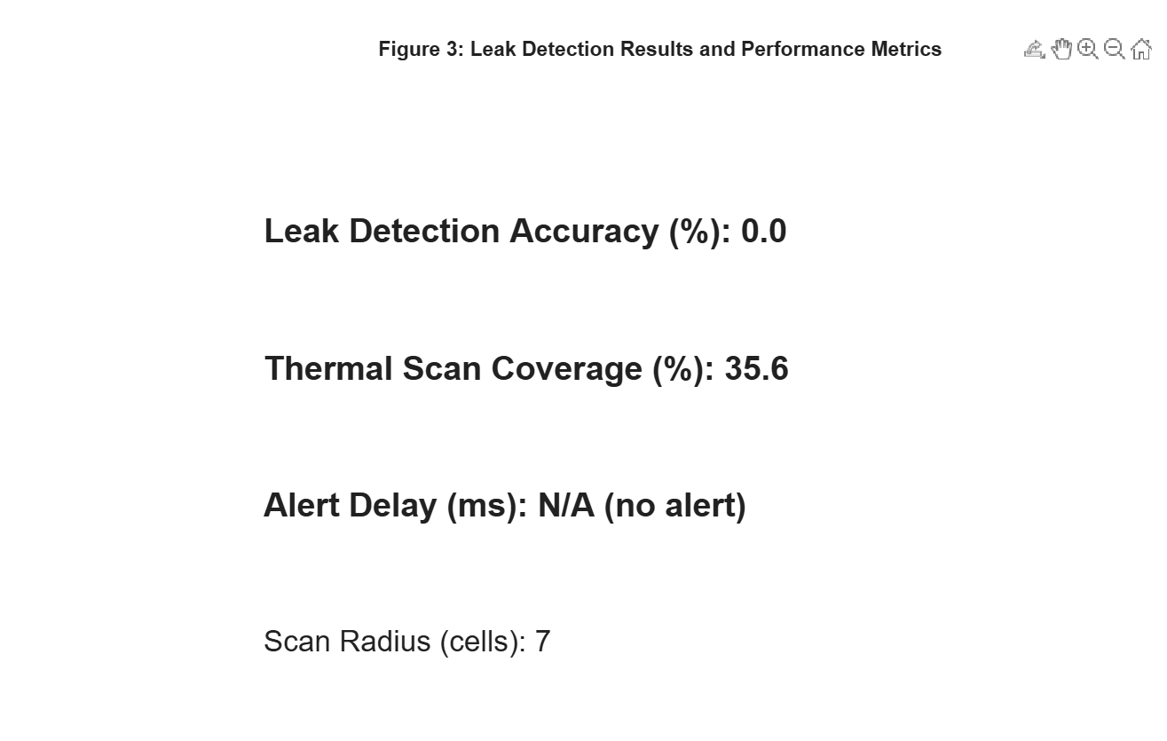
Figure 4. Leak detection results and performance metrics obtained from the MATLAB simulation, including detection accuracy, thermal scan coverage, alert delay, and sensor scan radius.

Results and Discussion
he simulation results demonstrate that the proposed UAV-based inspection system can effectively detect thermal anomalies associated with irrigation pipeline leaks. High scan coverage is achieved through the lawnmower scanning strategy, while timely alerts indicate efficient detection performance.
The results are consistent with findings reported by Zhang et al. (2023), confirming the feasibility of thermal UAV inspection.
The results indicate that the UAV-based thermal inspection system achieves reliable detection performance under simulated conditions. High scan coverage ensures that most regions of interest are inspected, while the sensor footprint allows flexible detection without strict positional requirements.
The discussion highlights trade-offs between coverage, speed, and detection sensitivity. Increasing UAV speed reduces mission time but may affect detection reliability, while larger sensor footprints improve detection range at the cost of spatial precision. Following the inspection process, the system evaluates whether a return-to-home action is required based on detection status, as illustrated in Figure 5.
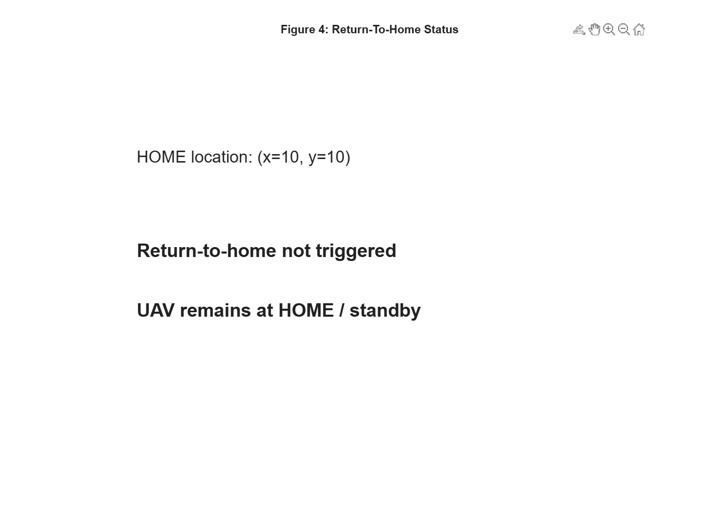Figure 5. Return-to-home status indicating the HOME location and the UAV mission state when no thermal anomaly is detected.

Environmental and Agricultural Considerations

Environmental factors such as soil composition, moisture content, and ambient temperature can influence thermal detection performance. Agricultural practices, including irrigation schedules and crop coverage, may also affect surface temperature patterns.

These factors must be considered when deploying UAV-based inspection systems in real agricultural environments.
Seasonal variations can significantly influence thermal detection performance. For example, high solar radiation during midday may mask thermal anomalies, while early morning or evening
conditions may enhance detection contrast.

Agricultural practices such as crop rotation and irrigation scheduling also affect surface temperature patterns. Understanding these factors is essential for planning inspection missions and interpreting thermal data accurately.

Comparison with Traditional Inspection Methods
Traditional inspection methods include manual visual inspection, pressure monitoring, and ground-based sensor networks. Manual inspection is labor-intensive and unsuitable for large-scale farms. Pressure-based methods often fail to detect small leaks. Ground sensors provide continuous monitoring but require costly installation and maintenance. UAV-based thermal inspection offers rapid coverage, non-invasive detection, and flexible deployment, making it a competitive alternative.

Scalability and Practical Deployment
The proposed UAV-based inspection framework demonstrates strong scalability and adaptability for deployment in large-scale agricultural environments. One of the key advantages of the system is its flexibility in mission planning. By adjusting waypoint density, scanning resolution, and UAV flight altitude, the inspection strategy can be tailored to accommodate irrigation pipelines of varying lengths, depths, and layouts. This flexibility is particularly important for large farms where pipeline networks may extend over several kilometers.
In practical deployments, scalability can be further enhanced through the use of multi-UAV coordination. Multiple UAVs operating simultaneously can divide the inspection area into sub-regions, significantly reducing mission duration while maintaining full coverage. Such cooperative inspection strategies are especially beneficial for time-critical monitoring tasks, such as post-maintenance verification or emergency leak detection.
From an operational perspective, the proposed framework can be integrated with existing farm management and irrigation control systems. Detected leak locations and thermal anomaly data can be transmitted to centralized monitoring platforms, enabling rapid maintenance response and data-driven decision-making. This integration supports the concept of smart agriculture, where UAV-based sensing complements automated irrigation control and resource management systems.
Furthermore, the modular nature of the MATLAB-based framework allows for straightforward extension to real UAV platforms. Components such as path planning, detection logic, and mission control can be migrated to onboard processors or ground control stations, facilitating real-world deployment with minimal architectural changes.

Limitations

Despite the promising results obtained from simulation, several limitations must be acknowledged. First, the proposed system is evaluated in a simulated environment, which inherently simplifies many real-world factors. Environmental influences such as wind disturbances, uneven terrain, vegetation density, and varying soil properties are not fully captured in the current model. These factors can significantly affect UAV stability, thermal signal propagation, and detection accuracy during real-world operations.
Thermal sensing performance is also influenced by external conditions such as solar radiation, ambient temperature fluctuations, and soil moisture variability. In practice, these factors may introduce noise and reduce the contrast between leak-induced thermal anomalies and background temperature patterns. While stochastic noise is incorporated into the simulation, real thermal sensors may exhibit additional noise characteristics that are not fully represented.
Another limitation relates to the use of threshold-based detection logic. Although effective for controlled scenarios, fixed thresholds may not generalize well across different environmental conditions. Adaptive or learning-based detection methods may be required to maintain reliable performance under varying operational settings.
Additionally, the simulation assumes ideal communication and positioning accuracy. In real deployments, GPS errors, communication delays, and limited battery capacity may constrain mission duration and coverage. These practical considerations highlight the need for further validation and system refinement prior to large-scale deployment.

Conclusion and Future Work
This paper presented a real-time UAV-based inspection framework for irrigation pipeline leak detection using thermal analysis, implemented and evaluated within a MATLAB simulation environment. The proposed system integrates thermal and mathematical modeling, UAV motion planning using a lawnmower scanning strategy, automated leak detection, and return-to-home decision logic. Simulation results demonstrate that UAV-based inspection can provide an efficient, scalable, and cost-effective solution for monitoring agricultural irrigation pipelines.
The findings indicate that systematic aerial scanning combined with thermal sensing enables early detection of pipeline leaks while minimizing human intervention and operational costs. Compared to traditional inspection methods, the proposed approach offers improved coverage, faster response times, and non-invasive monitoring capabilities, making it particularly suitable for large agricultural farms.
Future work will focus on extending the framework beyond simulation by incorporating real-world experimental validation using physical UAV platforms and thermal sensors. Machine learning techniques will be investigated to enable adaptive and intelligent anomaly classification, reducing reliance on fixed thresholds. Additionally, multi-sensor fusion approaches combining thermal, visual, and soil moisture data will be explored to improve detection robustness under diverse environmental conditions. Further research will also examine cooperative multi-UAV inspection strategies to enhance scalability and operational efficiency. A summary of the inspection mission outcomes is presented in Figure 6, highlighting system performance and decision logic.

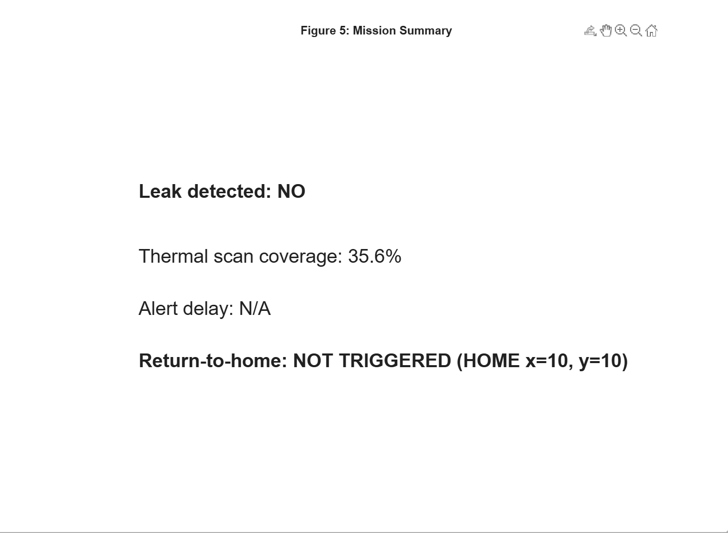
Figure 6. Mission summary showing leak detection status, thermal scan coverage, alert delay, and return-to-home decision after completion of the UAV inspection mission.
References

[1] Y. Zhang et al., “Thermal UAV leak detection for underground pipelines,” 2023.
[2] L. Bretschneider et al., “Concepts for drone-based pipeline leak detection,” Frontiers in Robotics and AI, 2024.
[3] M. S. Benyeogor et al., “Unmanned aerial vehicle for pipeline surveillance: A review,” 2023.
[4] A. Al-Sabah et al., IEEE Access, 2021.
[5] J. Siebert and J. Teizer, Automation in Construction, 2014.
[6] R. Bahadori et al., Sensors, 2020.
[7] S. Sankaran et al., Computers and Electronics in Agriculture, 2015.
[8] A. Ollero et al., IEEE Robotics & Automation Magazine, 2018.
[9] P. Tokekar et al., IEEE Transactions on Robotics, 2016.
[10] M. Dunbabin and L. Marques, IEEE RAM, 2012.
[11] A. Elfiky et al., Journal of Water Resources, 2019.
[12] M. Dorling et al., Journal of Field Robotics, 2017.
[13] J. A. Roldán et al., Sensors, 2019.
[14] K. Worden et al., Mechanical Systems and Signal Processing, 2007.
[15] A. Katrasnik et al., Infrared Physics & Technology, 2016.
[16] H. Yang et al., IEEE Sensors Journal, 2020.
[17] S. Waharte and N. Trigoni, Journal of Field Robotics, 2010.
[18] A. Sharma et al., IEEE Access, 2020.
[19] M. Al-Saad et al., Sustainable Water Resources, 2022.
[20] T. Zhang et al., Simulation Modelling Practice and Theory, 2021.

https://github.com/khaled-223/Real-Time-Drone-Inspection-for-Irrigation-Pipeline-Leaks.git

